Cruise report
HM20250091497

- Cruise overview
The cruise was organized to recover MF_inner in Masfjorden.

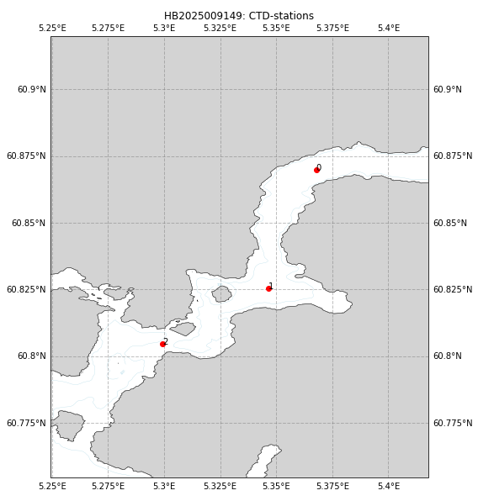
Figure 1; Map over the study area. The position of CTD-profiles are indicated by numbered red dots. Moorings were recovered at station 0 (MF_inner) and 2 (MF_sill).

- Cruise participants
Elin Darelius
Helge Bryhni

- CTD
We occupied a total of 3 CTD-casts during the cruise using the RBR Maestro sn 205914 available onboard. The conductivity, temperature and pressure sensor were last calibrated in February, 2025.
The stations are listed in Table 2.

- Water sampling
Water samples were obtained from the Rosette available onboard during the upcast. As CTD data cannot be viewed live, sample depths had to be chosen beforehand. Sample depths are listed in Table 3, where the depths are the depths given by the pressure sensor of the Rosette.
We waited at least one minute after the CTD was stopped before closing the bottle.
We took water samples for salt, dissolved oxygen following standard procedures.

Winkler titration
Samples for measuring dissolved oxygen were collected using a tube, ensuring that each sample was as bubble-free and exposed to air as little as possible. Draw temp was measured before we added 1 mL MnCl2 and 1 mL NaOH/NaI to the sample and put a cap on the flask. The sample was then shaken for about 20 sec, and stored dark and cool until Winkler titration started.
Winkler titration was carried out onboard by Kristin M. Jackson and the students using the semi-manual titration system.

- Salinity
The samples were collected following standard procedures, i.e., the bottles were rinsed three times and then brought back to GFI, where they were analyzed in the lab by the students, supervised by K. Jackson-Misje.

- Mooring recovery
Moorings “MF_inner” and “MF_sill”, were recovered without any problems (See Table 1 and Figure 5-6.) We were prepared to dredge for MF_inner as we have tried to recover it previously without success. We a) used a longer cable for the hydrophone and b) released the mooring from a relatively large distance (1.7 km) and it then released on the first try.
Table 1: Mooring details
 | Lon | Lat | Date in | Date out | Depth | CTD
MF_sill | 5° 17.897'E | 60°48.2302′ N | 2025.03.11 14:17 | 2025.12.02 12:45 | 82 m | 1
MF_inner | 5° 22.0148’E | 60° 52,198’N | 2024.04.04 07:40 | 2025.12.02 10:05 | 462 m | 0

The time of the SBE37s matched that of the computer to within the minute (7536, 7550, 7553, 7554)
The Seaguard was out of battery.
Data from the ADCP at the sill that did not fulfill the criteria below were removed:
- Pitch and roll < 20º.
- Relative error < 0.5
- Echo intensity > 40
-percent good > 50
- distance from surface > 10m

- Calibration of CTD sensors
- Salinity
The salinity of the five water samples collected was determined by K. Jackson a portasal. One of the samples was collected in a gradient, and was therefore flagged. The number of water samples is too low to calibrate the data, but the error is likely smaller than 0.01 g/ kg.
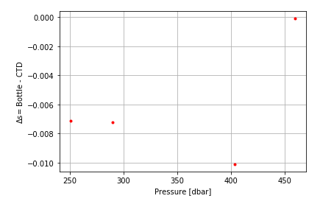
Figure 2: Difference between the salinity observed with the CTD and the salinity from the water samples as a function of pressure.
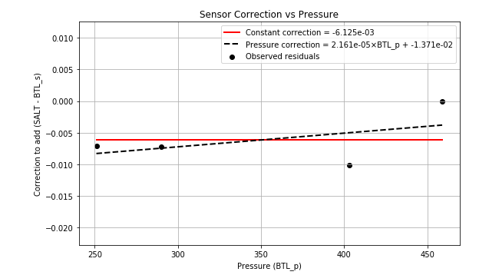
Figure 3: Salinity difference between the salinity value from bottles and the CTD. The black line shows the mean value, and the dashed lines show the mean value +/—2 times the standard deviation. Outliers are marked with black squares.
There appears to be some form of pressure lag – as salinity typically increases (by about 0.003-0.004 when the CTD is stopped at the bottom. There is no similar effect in the oxygen data. The figure below shows the raw data from the RBR-sonde (cast 0) as a function of time.
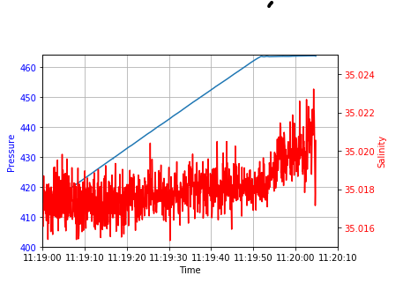

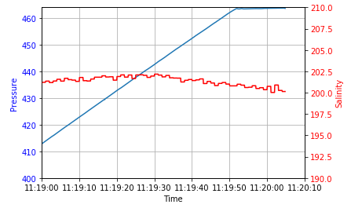

- Dissolved Oxygen
Oxygen concentrations observed by the CTD and those determined through manual Winkler titration were converted to [umol/kg] and compared.
Samples collected at depth shallower than 100 m were excluded from the analysis.
No sample was flagged as bad during the analysis. When the difference between doubles (samples taken from the same depth and station, but not necessarily the same Niskin) was lower than 3 umol/kg, the mean value was retained. If the value was higher than 3 umol/kg both samples were removed. All three doubles where retained.
We fitted a line to the data using linear regression, and samples with an error larger than 2.5 times the root mean square error were removed. This procedure was repeated until either no more samples were removed, or the root means square error of the remaining samples was smaller than 2 umol/kg.
A total of 6 samples were included in the regression analysis, and 5 samples were included in the final regression (Fig. 4).

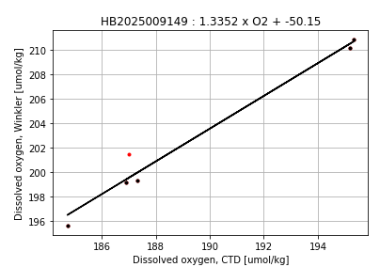
Figure 4: Dissolved oxygen concentration observed with the CTD versus that determined through Winkler titration. The black line shows the regression line used to correct the CTD data, and the black (red) dots are the samples included (not included) in the final regression analysis.
- Cruise diary
2 December
07:00 Loaded the ship
07:15 Departure from Bergen

Table 2: Details about CTD-stations occupied during HB20250091947.
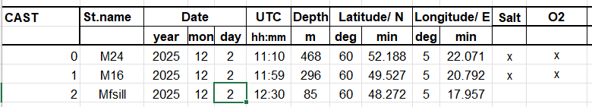

Table 3: Pressure (dbar) where the Niskin bottles were closed.
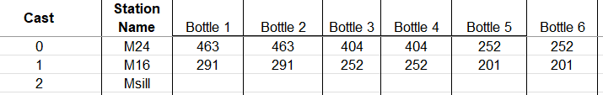
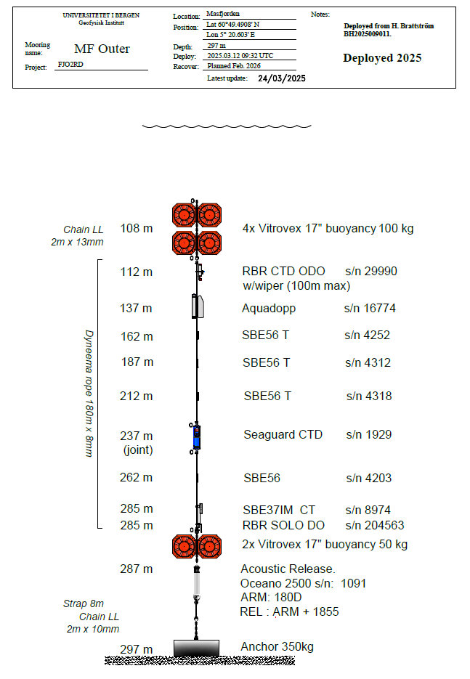
Figure 5: Mooring drawing MF_outer
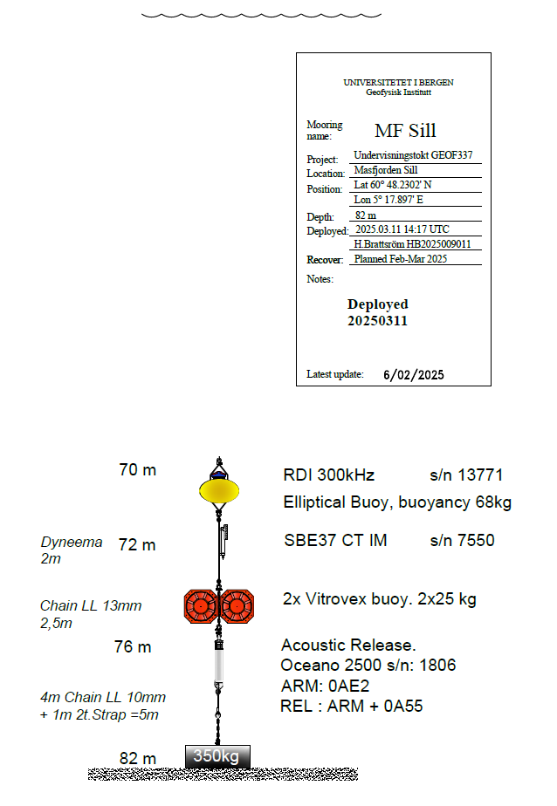
Figure 6: Mooring drawing, MF_sill

